# Get Team Names with Correlated Subqueries

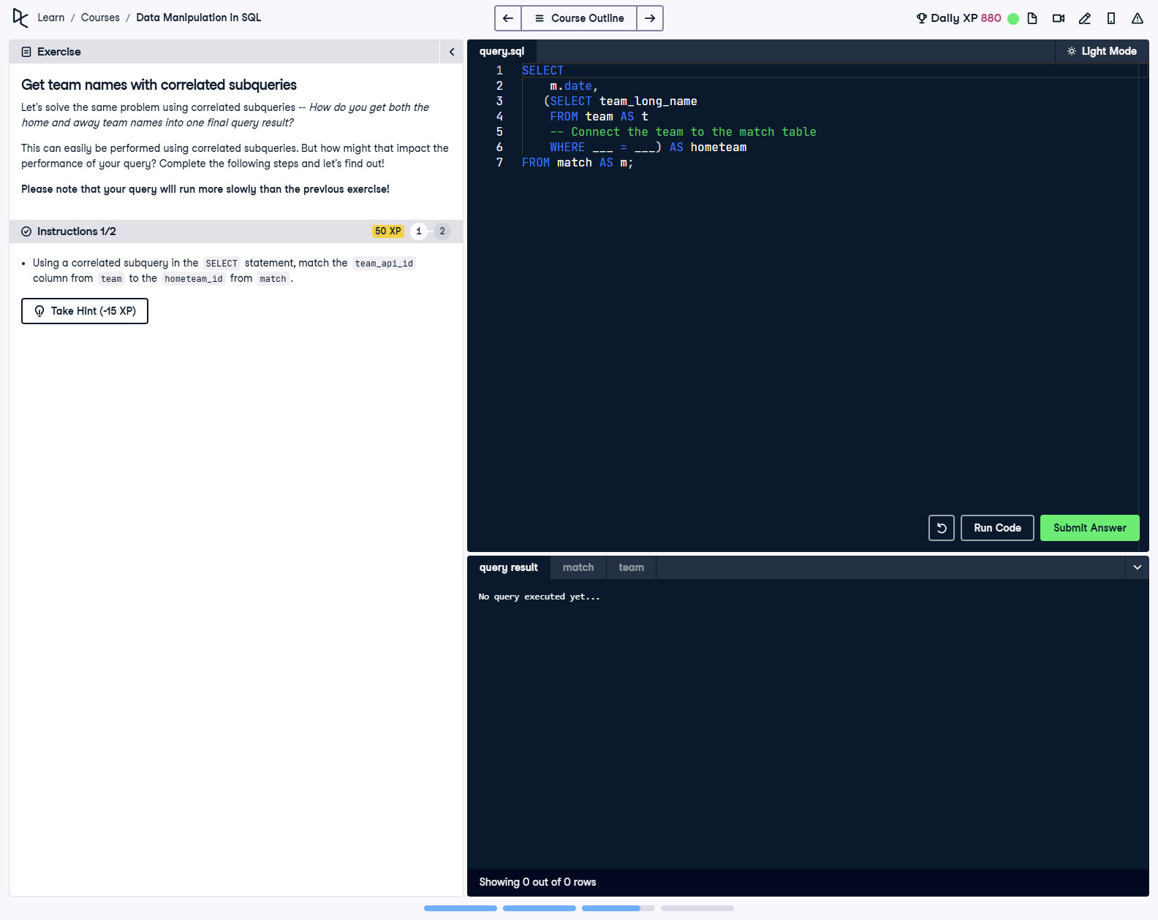

## Question

1. Using a correlated subquery in the SELECT statement, match the team_api_id column from team to the hometeam_id from match.

## Corrected Solution

SELECT  
 m.date,  
 -- Using a correlated subquery to retrieve home team names  
 (SELECT t.team_long_name  
 FROM team AS t  
 WHERE t.team_api_id = m.hometeam_id) AS hometeam  
FROM match AS m;

## Explanation

This query uses a correlated subquery to retrieve the home team name for each match. The subquery dynamically fetches the team_long_name from the team table by matching the hometeam_id in the match table with the team_api_id in the team table. The main query retrieves the match date and the home team name for each match. While this approach is flexible, it may be slower than using joins due to the subquery being executed for each row.